**Circuit Simulation Project**

[**https://esim.fossee.in/circuit-simulation-project**](https://esim.fossee.in)

**Name of the participant : Nunna Lakshmi Saranya**

**Title of the circuit : Jhonson counter**

**Theory/Description :** The **Johnson Ring Counter** or “Twisted Ring Counters”, is another shift register with feedback exactly the same as the standard Ring Counter , except that the inverted output Q of the last flip-flop is now connected back to the input D of the first flip-flop.

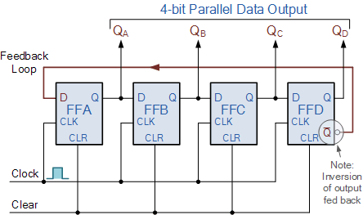

This inversion of Q before it is fed back to input D causes the counter to “count” in a different way. Instead of counting through a fixed set of patterns like the normal ring counter such as for a 4-bit counter, “0001”(1), “0010”(2), “0100”(4), “1000”(8) and repeat, the Johnson counter counts up and then down as the initial logic “1” passes through it to the right replacing the preceding logic “0”.

A 4-bit Johnson ring counter passes blocks of four logic “0” and then four logic “1” thereby producing an 8-bit pattern. As the inverted output Q is connected to the input D this 8-bit pattern continually repeats. For example, “1000”, “1100”, “1110”, “1111”, “0111”, “0011”, “0001”, “0000” and this is demonstrated in the following table below.

**Circuit Diagram(s) :**

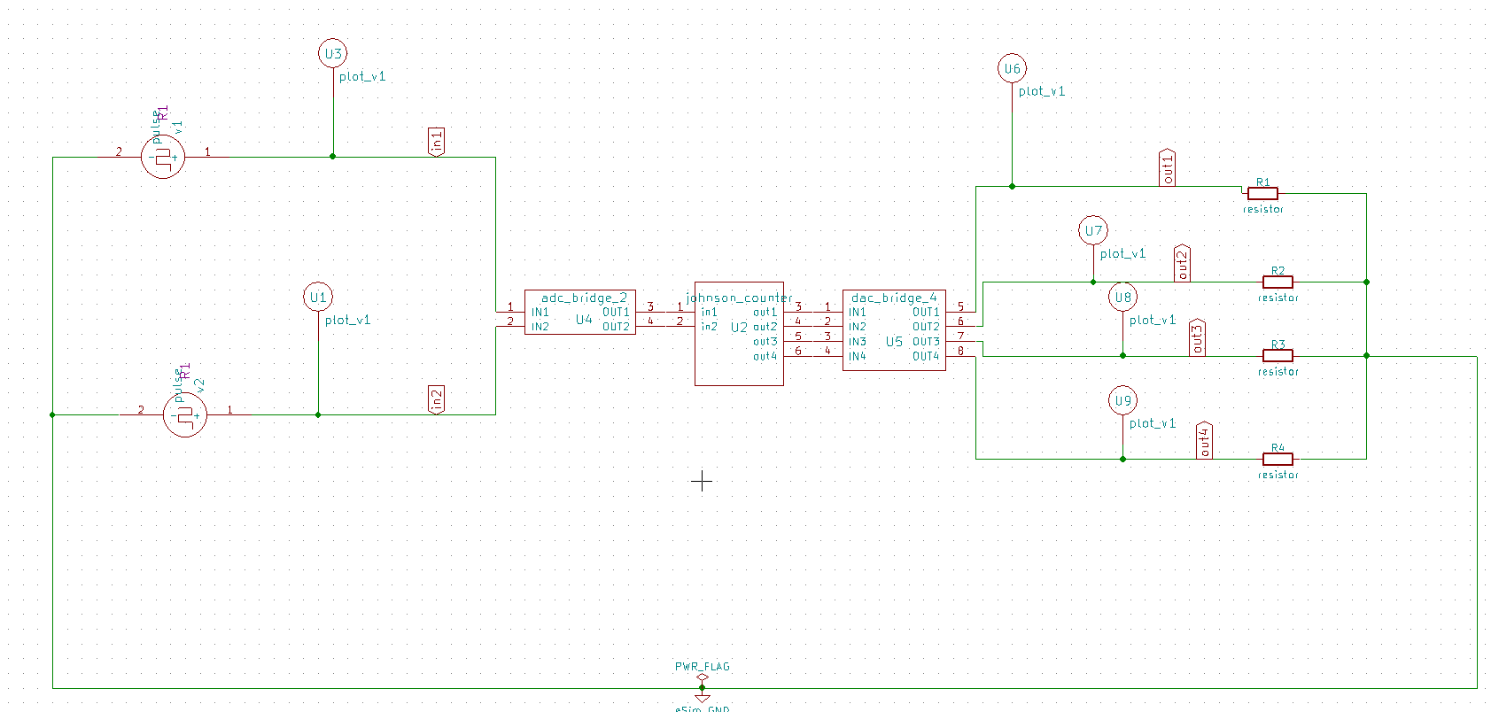

**Results (Input, Output waveforms and/or Multimeter readings) :**

**Clk(in1)-**

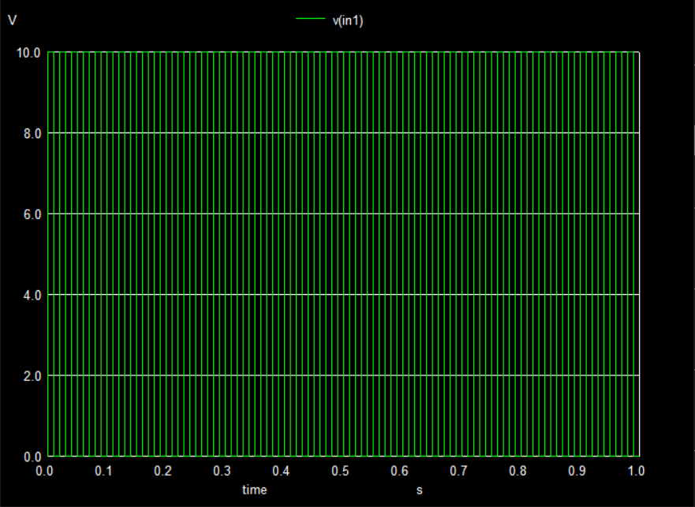

Reset (in2) -

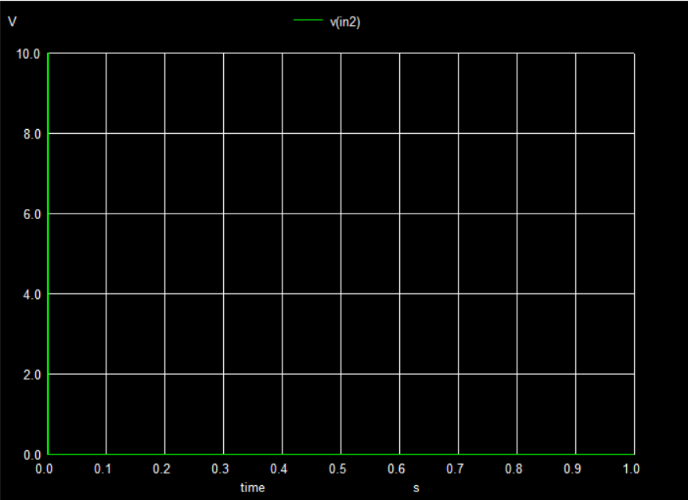

**Output waveforms-**

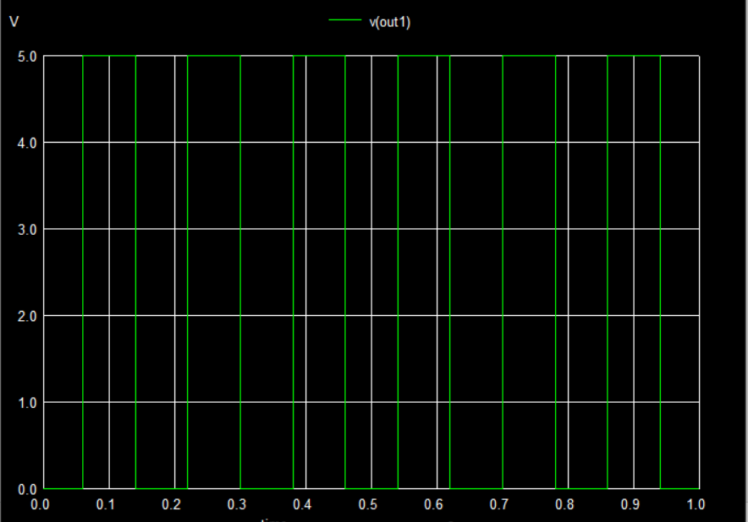

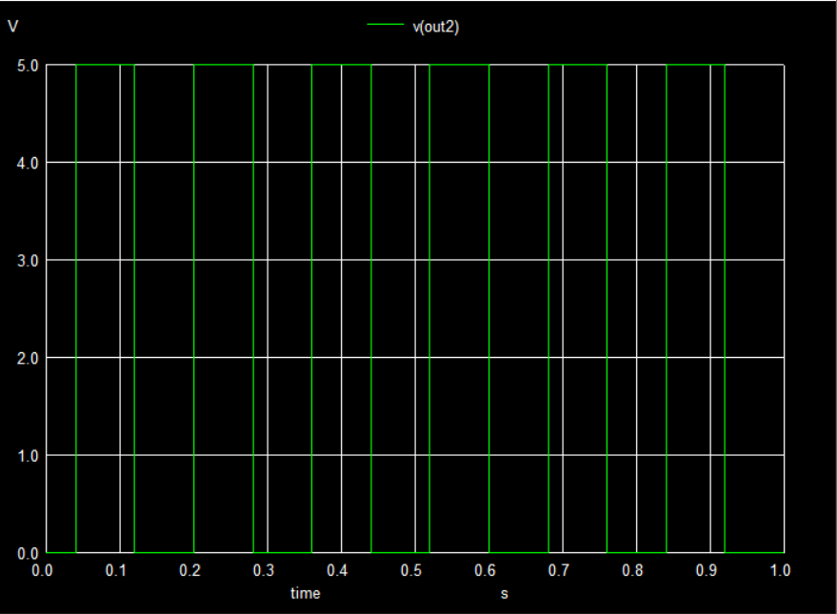

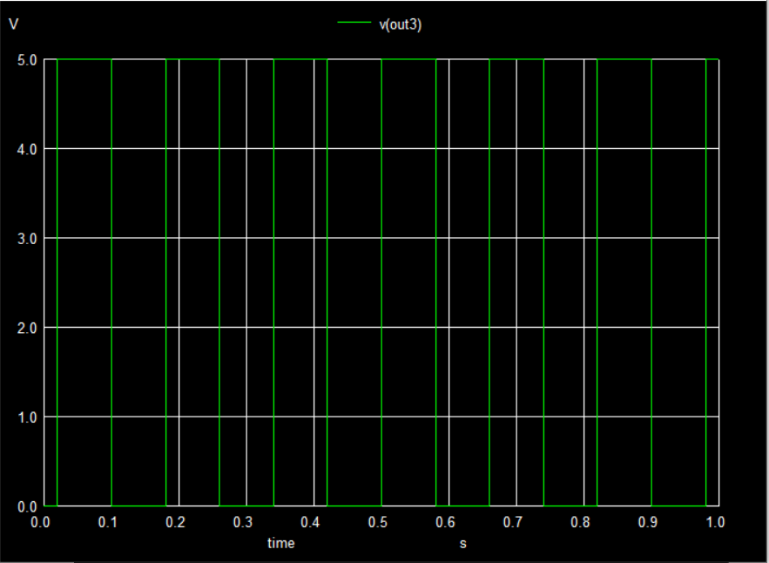

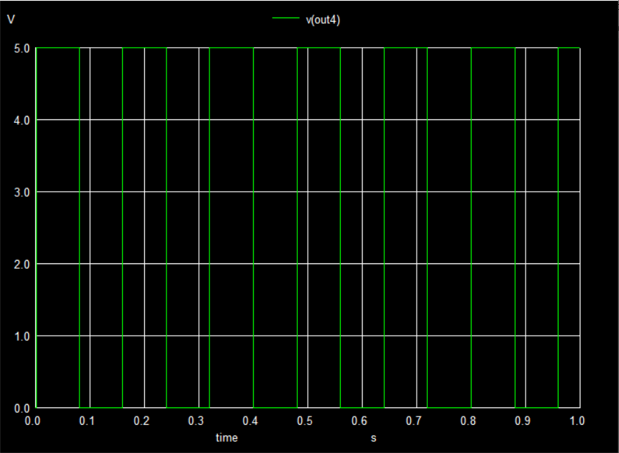

**Python plots**

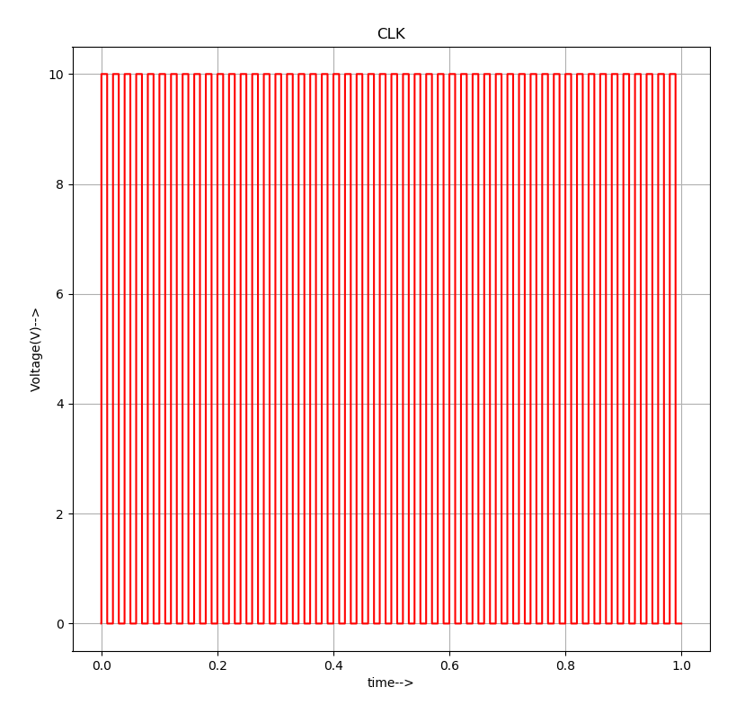

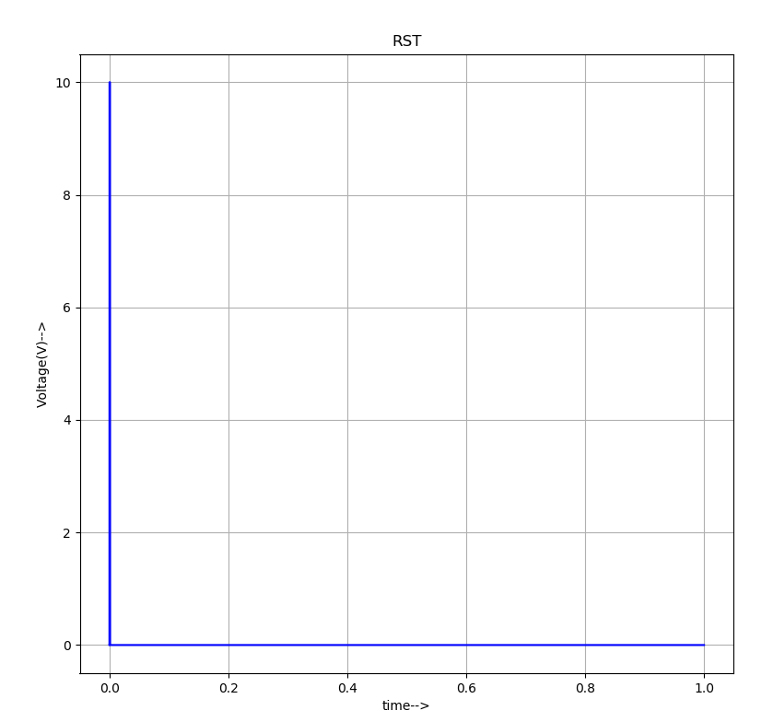

**Output plots -**

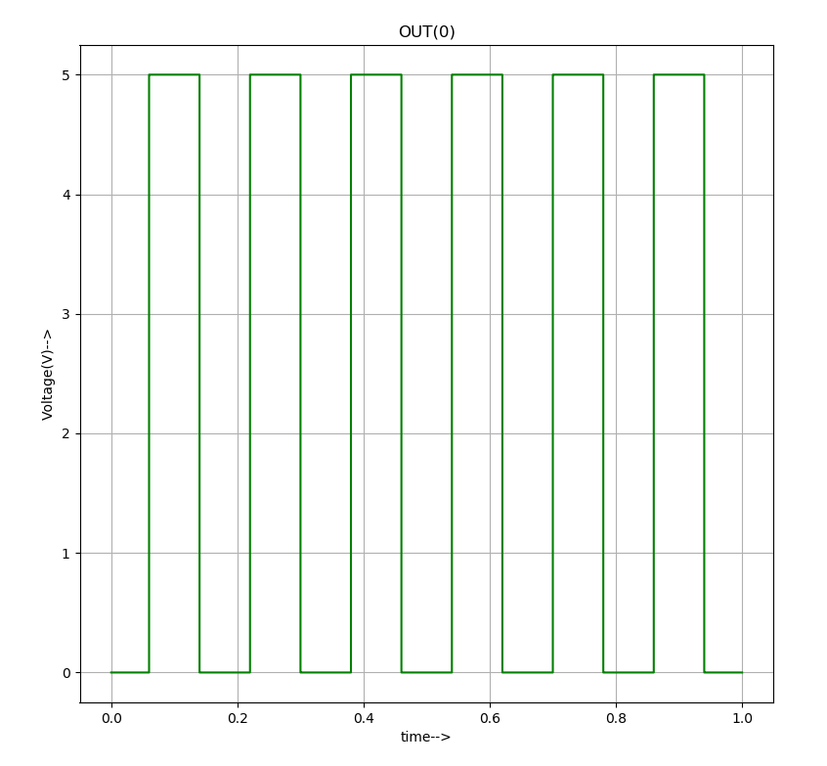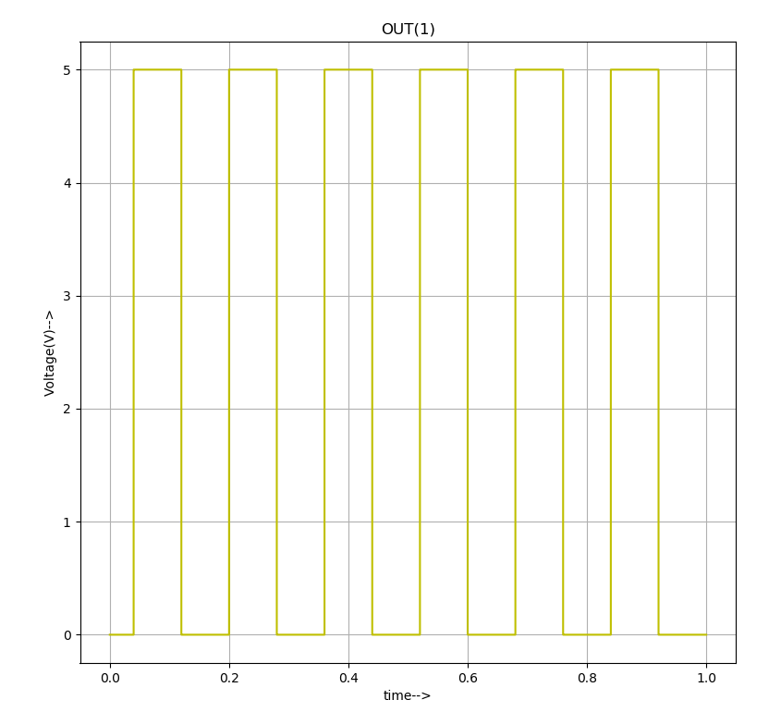

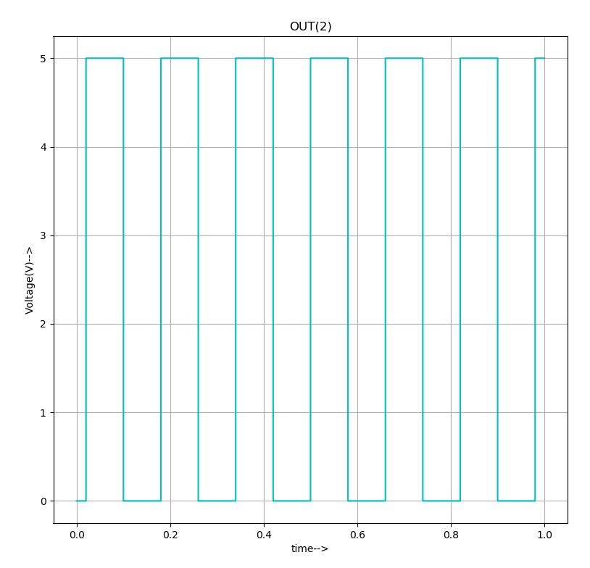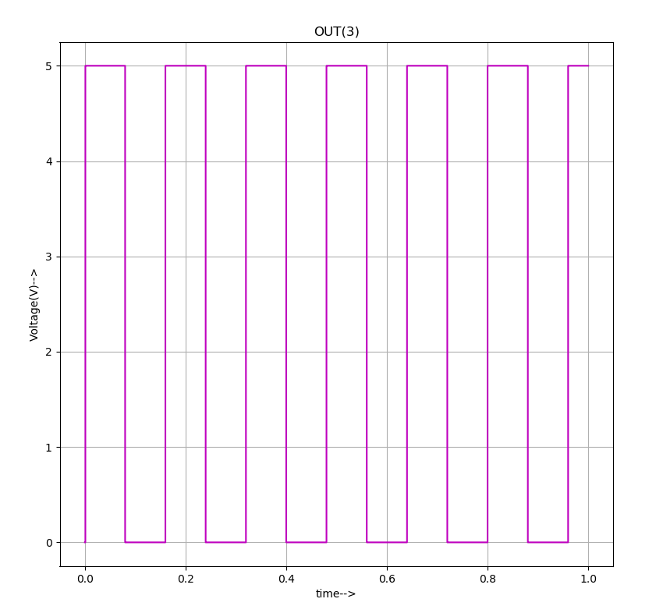

**Table-**

|  |  |  |  |  |  |
| --- | --- | --- | --- | --- | --- |
| Clk | Reset | Out[0] | Out[1] | Out[2] | Out[3] |
| **0** | **1** | **0** | **0** | **0** | **0** |
| **1** | **0** | **1** | **0** | **0** | **0** |
| **2** | **0** | **1** | **1** | **0** | **0** |
| **3** | **0** | **1** | **1** | **1** | **0** |
| **4** | **0** | **1** | **1** | **1** | **1** |
| **5** | **0** | **0** | **1** | **1** | **1** |
| **6** | **0** | **0** | **0** | **1** | **1** |
| **7** | **0** | **0** | **0** | **0** | **1** |

**Source/Reference(s) :**

**Information about jhonson counter is from** [**https://www.electronics-tutorials.ws/sequential/seq_6.html**](https://www.electronics-tutorials.ws/sequential/seq_6.html)